How to send secure emails using zsecure for Cranbrook Emails.

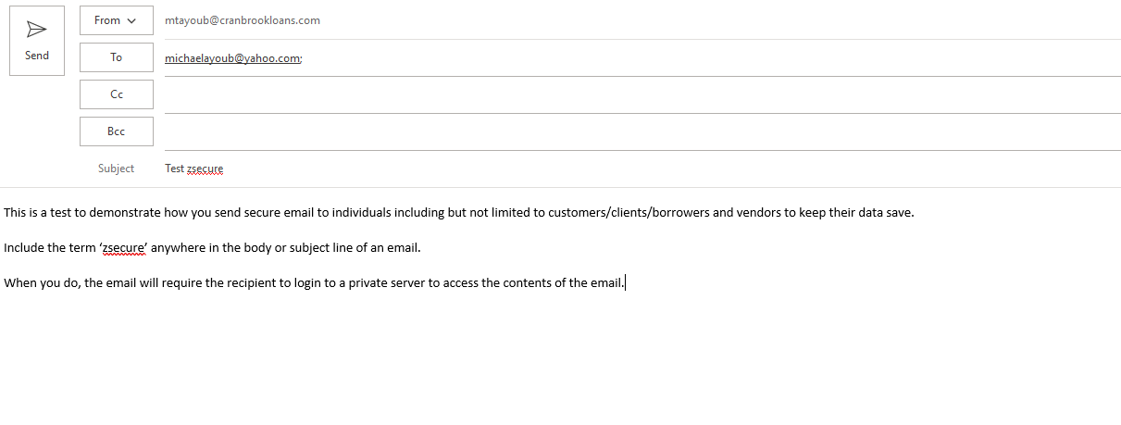

This is what the email will look like:
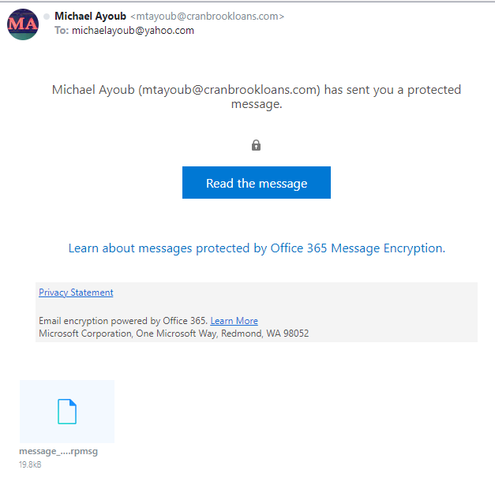

Once a user clicks “Read the message” this comes up:
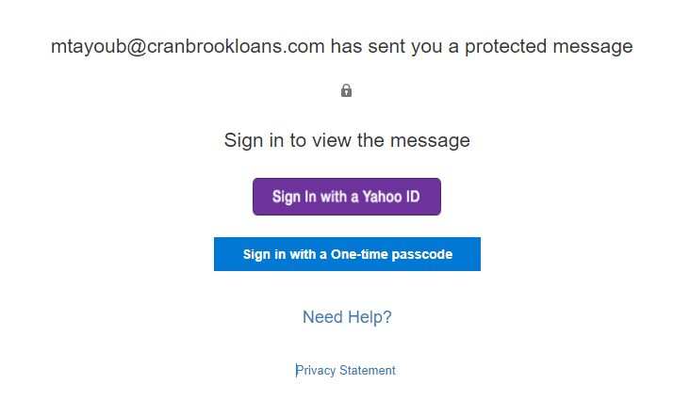

Once you click ‘Sign in with a One-time passcode’ the following message comes up.

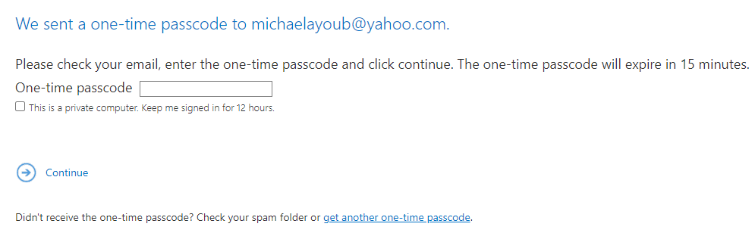
Upon checking the email this arrives:
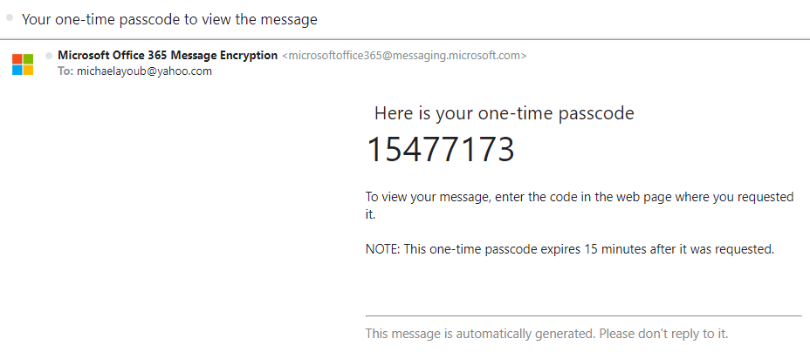
Insert passcode into website within 15 minutes, like this and click continue:
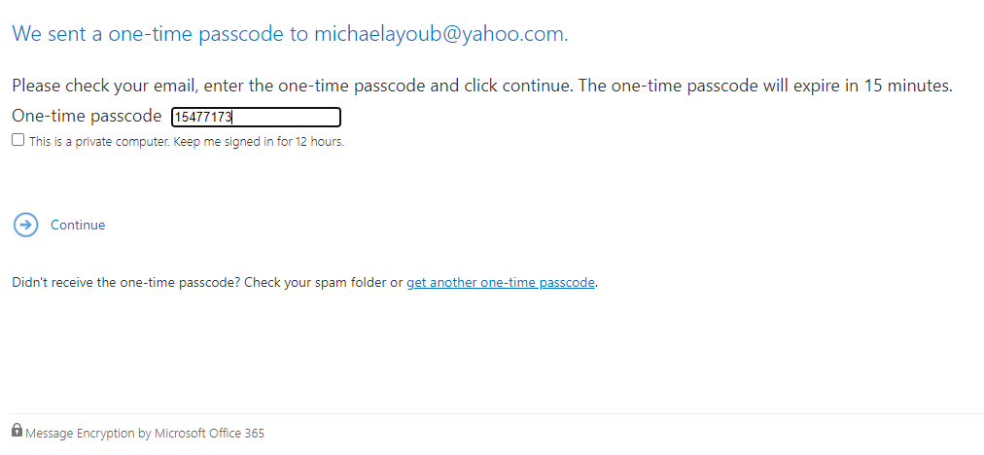

After this the secure message displays. Here is the message.
