How to access documents in Sharepoint
Goto: https://cranbrookloans.sharepoint.com/
This is also accessible from Teams, but this training focuses on Sharepoint instructions.
Login with your cranbrookloans.com email credentials which include a user id which is your email and your password for your email account.
Search for PDrive and Click PDrive: (if its not accessible, please reach out to Roger in IT Support)
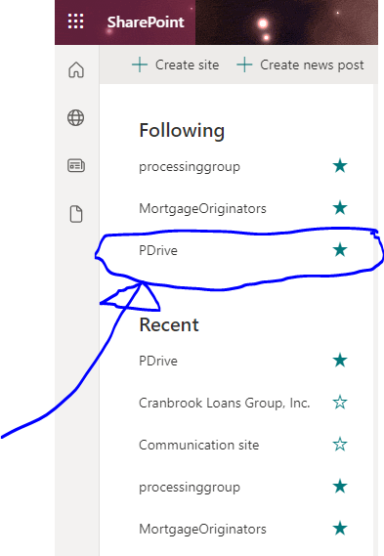

Once you click on PDrive, you will see this menu.
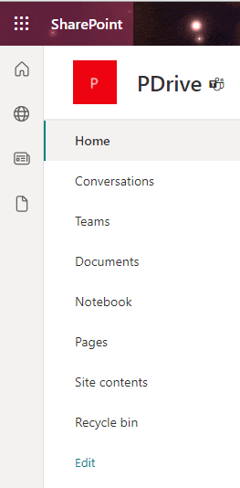

Click Documents:
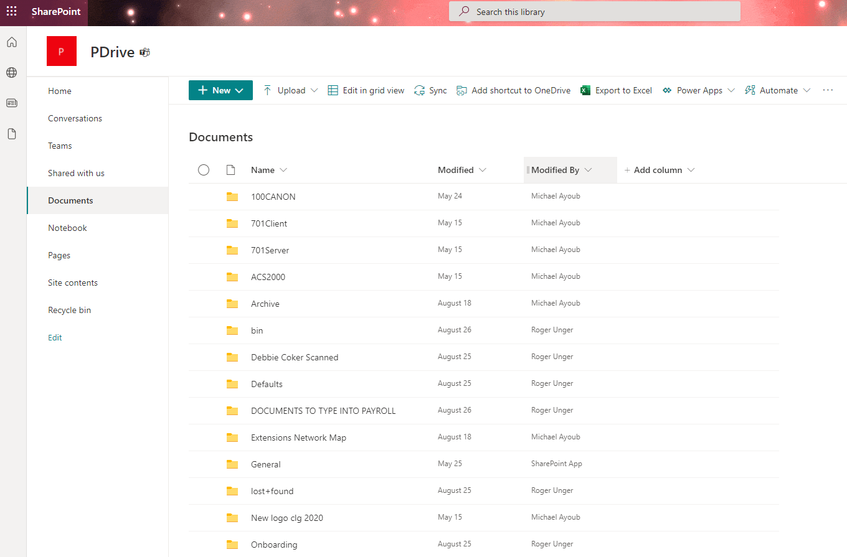
Scroll down to the document folder you’re looking for, i.e. Policies, once you click on policies you may find the Employee Handbook, click on the file to open the folder. If you don’t have access you can request permission.
End of training.

